**Sleeping Behind the Wheel: Examining the Effect of Daylight Savings Time Implementation on Fatal Traffic Accidents**

Tristan Moser

Brigham Young University

**Introduction**

Daylight Savings Time (DST) is a worldwide policy that affects over 1.6 billion people every year in the effort to reduce energy consumption. Much research has been conducted by government agencies and scholars to examine whether DST is achieving its goal. Alternatively, research has also been conducted to examine other adverse effects caused by “springing forward” or “falling backward”. This paper aims to add to this area of research by examining the effect of DST implementation on the amount of car crashes that result in fatalities. I specifically look at how DST implementation affects the observance of car crash fatalities. This analysis includes both losing one hour during the spring and gaining one hour during the fall.

Using data from all US counties over the span of six years, I provide new evidence suggesting that losing an hour of time during the spring DST transition results in an increased amount of fatal car accidents the week following the transition. Specifically, my findings suggest an increase of 26 fatal car accidents across the United States following the spring DST transition. I find no evidence suggesting any change in the amount of fatal accidents following the fall transition period. These results are consistent with the current literature in this area.

My methodology includes a simple Regression Discontinuity design that examines the immediate effect of DST by comparing the weeks just before and after the transition. While the design is simple, the results are shown to be robust with other specifications.

My analysis is presented in the following format. First, a brief history of Daylight Savings Time is given along with research that estimates the effects of its implementation. I then present my empirical strategy including the data used for this study. Next, I provide the results found from my analysis. A conclusion of the study is then given.

**COSTS OF DAYLIGHT SAVINGS: Background and Previous Studies**

Daylight Savings Time (DST) was first introduced by Benjamin Franklin in the late 1700s as a way to make better use of the light during spring and summer months. The main motive for DST countries is to reduce energy. The most recent example is The Energy Policy Act of 2005 that was passed in the United States. The effect of this bill on DST was that it made the period in which the US used DST increase. The US Department of Energy found evidence supporting the passing of the bill. They calculated that DST saved roughly 0.03 percent of total annual energy consumption the year following The Energy Policy Act (Belzer, 2008).

While evidence shows that energy costs can be lowered, many Americans express disinterest in the policy and have urged policymakers to propose bills to stop it. Examples of this can be seen in Utah and Florida with bills SCR5 and the Sunshine Protection Act respectively. Both bills aim to remove the DST time transitions as the voice of the people seem to agree that they do not wish to continue changing their clocks. In an effort to make lawmakers more informed of the consequences of DST, many scholars have conducted research to show the negative effects of DST implementation.

It may be true that DST overall decreases energy consumption, but many countries apply unexpected costs to their citizens upon its implementation. Jankszky et al. (2012) found that heart attacks increase following DST implementation. It is likely that the patients who experienced heart attacks had pre-existing conditions that would have led to heart attacks with or without DST. However, their results suggest that the actual implementation of losing an hour of time acts as a stressor that stimulates the negative health response.

The adverse effects of Daylight Savings implementation are not limited to health outcomes. Kamstra et al. (2000) examined the effect of DST on the stock market. They estimate an effect of a one-day loss of $31 Billion the day after the DST transition. These estimates are significantly larger than any normal “weekend effect”. Similarly, a study conducted by the JP Morgan Chase Institute found that while consumer spending increases during the spring DST transition, the decrease during the fall outweighs the spring increase which leads to an overall decrease due to DST (Farrel et al, 2007).

Other behavioral studies have linked DST implementation to negative outcomes due to sleep deprivation. Barnes and Wagner (2009) show that injuries that occur in the workplace, and injury severity, also increase due to the hour lost by DST. DST sleep loss has also been shown to adversely affect workplace productivity (Wagner et al, 2012) and sentences handed down by judges (Cho et al, 2017).

In the light of my own research, Smith (2014) has estimated an increase in fatal car accidents of approximately 6% across the United States following the Spring DST transition. His estimates focus on the day-to-day increase in fatal accidents following DST implementation as well as examining the effect of the US changing length of DST. While his evidence is compelling, my analysis differs in two ways. First, I look specifically at states that practice DST within a time period where no change in DST policy occurred. Second, my estimates focus on the weekly impact of DST instead of the daily effect. Through my analysis, I offer more evidence that can be informative to policy makers as they determine the future of DST in the US.

**DATA**

My primary source of data for this study was collected from the National Highway Traffic Safety Administration using their Fatality Analysis Reporting System (FARS). The FARS database records relevant information regarding all fatal car accidents that occur within the United States. Each crash has detailed information about the driver, vehicle, location and time of the crash. For my analysis I focus on crash data from the recent years 2010 to 2015 from all states that follow DST. Isolating the analysis to these years allows for analyzing the current policy followed by the states in my sample as no state has policy changes during the sample time. Arizona and Hawaii were excluded due to the fact that they do not follow DST.

Because I hypothesize that the effect of DST lasts for a week, the unit of observation is a county-week. Due to the fact that not every county has a fatal car accident each week of the year, extensive data cleaning was performed to organize the data in the necessary format. The result was each county being represented for all 52 weeks of every year. My dependent variable, the number of fatal crashes, was recorded based on how many observations occurred within the county during the specified week. Similarly, the weather for each week was recorded by taking the most frequent weather indicator in the county for the given week. Other variables extracted from FARS include state and week of the year.

To address the main independent variable of interest, an indicator variable (DST) was created based on whether the week of the year was the week following DST implementation for spring or fall in the given year. Similarly, a running variable of weeks from DST was also calculated centering on the transition week for each year. This variable is negative for weeks approaching DST and positive for weeks after.

Data was also collected from the Urban Institute’s database of US government census financial records, the US Energy Information Association (EDI), as well as the US census. The Urban Institute data was used to address the state finances in regards to: total highway expenditure, tax on gasoline, and tax on driver’s licenses. From the US census I take population data for each state. These data provide controls for certain specifications to be discussed later in further detail. Data from the EIA includes average, weekly gasoline prices to proxy the demand for driving. The use of this data will be examined later.

Summary statistics of my data are provided below in Tables 1 and 2. Table 1 summarizes the financial and population data for each year. Similarly, Table 2 summarizes the weather variable. To provide a comparison for each year, the last column is the average across all years. It is clear that the data is similar for each year suggesting that there should be no problem in combining the datasets. It is interesting to note that the average amount of fatal crashes per county per week is approximately 0.179. Considering that the United States has over 3,000 counties, almost 537 fatal accidents occur every week in the US.

**Empirical Strategy**

*Regression Discontinuity Framework*

To identify the effect of spring DST transition on the amount of fatal car accidents, I use the identification strategy of a regression discontinuity (RD) design. The RD design fits well with this problem because there is a clear distinction of when DST begins in spring and fall every year. With a specific time to look at, a RD design allows inference to be made between weeks just before and after the transition time. Specifically, I implement a local linear regression RD technique that takes only the observations within 10 weeks of each transition. This technique has been shown to produce efficient estimates of RD problems (Imbens, 2008). The framework for the model is as follows:

*Fatal Accidentsᵢ = ⍺ +βDSTᵢ + ɸProxᵢ + εᵢ*

The i subscript on all variables identifies the specific county-week observation. Fatal accidents denote the dependent variable specified earlier: the number of fatal car accidents that occur in a county-week. The independent variable of interest is the DST indicator. A value of one indicates that the week is the DST transition week. Prox is the running variable that shows how many weeks from the DST transition week the observation week is. As I only focus on observations within ten weeks, Prox ranges from -10 to 10.

In order to trust the results of this model, its assumptions must hold. The main assumption of the RD model is that weeks before and after the DST transition are similar in all regards except for the desired discontinuity. To show evidence that this assumption holds, I present data on the average price of gasoline for the weeks surrounding the transition week from 2010 to 2015. This data serves as a proxy to reflect the average demand for driving through the specified time interval. The data is illustrated in Figures 1 and 2 where it can clearly be seen there is a continuous trend. This indicates that drivers are not choosing to drive any more or less around the transition period.

Intuition also provides us with this result as drivers cannot reasonably choose to avoid the DST implementation week. All citizens of states that practice DST lose or gain an hour of time regardless of their personal choices. There is also little to no evidence suggesting a significant change in one’s day-to-day schedule the week of DST implementation. People retain the same responsibilities through the transition. In the case of spring DST, it is true that one could sleep for one additional hour. It is unlikely, however, that that will provide sufficient change to offset the complete change of schedule that a person experiences with the loss of one hour.

*Other Specifications*

In addition to the standard Regression Discontinuity design, I implement other specifications to offer robustness of the estimates that are found. Each specification adds on to the previously examined specification.

First, I cluster my observations by county as there are likely similarities within each county that could lead to improper standard errors when not accounted for. The second specification includes both state and year dummy variables. This accounts for differences in the estimates that are caused by state or year differences. The third specification adds additional control variables to account for differences caused by gasoline tax, driver’s license tax, total highway expenditure, state population, and weather. This specification offers a comparison to see if there is potential bias in the RD estimates caused by omitted variables.

**RESULTS**

*Spring DST*

Using the framework and specifications outlined in the previous section, the results of the estimated impact of the spring DST transition are displayed in Table 3. Each column indicates the results for each specification. The simple RD design shown in column one estimates an increase of 0.00883 in fatal accidents following the spring DST transition significant at the five percent level. The subsequent columns produce similar results with slightly higher coefficients of 0.00986 for the fixed effects specification and 0.00917 when adding control variables. Overall this suggests a robust estimate that is significantly positive.

Figure 3 represents the amount of average fatal accidents by proximity to the DST transition week. It can clearly be seen that there is a jump just as the transition occurs. Upon further inspection, the jump can be approximated to represent an increase of about 0.008. These results further support the estimate found from the regression output.

*Fall DST*

Following the same structure as spring, the fall regression results are shown in Table 4. In all specifications I find no significant effect of fall DST implementation on fatal accidents. This is further supported with the graph displayed in Figure 4. The figure shows the average amount of crashes through the fall transition. While there is some evidence of a change in slope, there does not appear to be any discontinuity.

**CONCLUSION**

My analysis has estimated the effect of implementing DST on the amount of fatal car accidents that occur the week following the transition. The results I find are consistent with other research which shows that DST implementation has adverse effects on those who practice the policy. Specifically, I find that fatal accidents increase, on average, between approximately 0.008 and 0.009 per county the week following the spring DST transition. While it is difficult to interpret an increase of a fraction of an accident, the metric becomes much more clear when one considers that the United States has just over 3,000 counties. When counties from Hawaii and Arizona are excluded, my results estimate roughly 26 fatal accidents are caused by DST the week following its spring implementation.

The data used for this study included only the number of fatal car accidents and not the actual amount of individuals who died due to the crash. This limitation only allows me to create a lower bound of the potential crash deaths caused by DST. Even with this lower bound, I estimate that the financial cost of these deaths to be approximately $192.4 million when using the US Environmental Protection Agency’s value of a statistical life.

This cost analysis begs the question: Is saving energy worth the associated costs and loss of life? Yes, the US Department of Energy found overall energy savings of 0.03 percent over a year, but they did not estimate the financial savings associated with it. It is more than likely that millions of dollars are saved from the reduced energy consumption, but do these benefits outweigh the costs? Is it morally correct to allow this policy to continue to take lives? I leave these questions to the policymakers who must decide on current legislation regarding DST.

**TABLES AND FIGURES**

|  |  |  |  |  |  |  |  |  |
| --- | --- | --- | --- | --- | --- | --- | --- | --- |
| Table 1 - Summary Statistics (Continuous Variables) | | | | | | | | |
|  |  | Means (Standard Errors in Parentheses) | | | | | | |
|  |  | Year | | | | | | |
| Variable |  | 2010 | 2011 | 2012 | 2013 | 2014 | 2015 | Average |
| State Population | | 15.533 | 15.540 | 15.472 | 15.554 | 15.561 | 15.568 | 15.538 |
|  |  | (0.946) | (0.947) | (0.948) | (0.948) | (0.948) | (0.950) | (0.948) |
|  |  |  |  |  |  |  |  |  |
| Tax on Fuel |  | 13.479 | 13.521 | 13.532 | 13.538 | 13.553 | 13.584 | 13.535 |
|  |  | (0.872) | (0.878) | (0.880) | (0.878) | (0.879) | (0.878) | (0.878) |
|  |  |  |  |  |  |  |  |  |
| Tax on Licenses | | 13.588 | 13.617 | 13.66 | 13.686 | 13.62 | 13.645 | 13.636 |
|  |  | (1.040) | (1.044 ) | (1.070) | (1.073) | (0.944) | (0.919) | (1.015) |
|  |  |  |  |  |  |  |  |  |
| Total Highway | | 14.407 | 14.408 | 14.453 | 14.428 | 14.468 | 14.491 | 14.443 |
| Expenditure | | (0 .719) | (0.725) | (0.727) | (0.751) | (0.765) | (0.772) | (0.748) |
|  |  |  |  |  |  |  |  |  |
| Crashes |  | 0.177 | 0.174 | 0.181 | 0.176 | 0.176 | 0.189 | 0.179 |
| (per county per week) | | (0.559) | (0.555) | (0.578) | (0.574) | (0.586) | (0.614) | (0.578) |
|  |  |  |  |  |  |  |  |  |
| Observations | | 165,307 | 165,307 | 165,307 | 165,307 | 165,307 | 165,307 | 165,307 |

*All variables shown, except for crashes, are the natural log of their respective quantity.*

|  |  |  |  |  |  |  |  |  |
| --- | --- | --- | --- | --- | --- | --- | --- | --- |
| Table 2 - Summary Statistics (Weather) | | | | | | | | |
|  |  | Frequencies (Percentages in Parentheses) | | | | | | |
|  |  | Year | | | | | | |
| Variable |  | 2010 | 2011 | 2012 | 2013 | 2014 | 2015 | Average |
| Blowing Sand or Dirt | | 78 | 56 | 42 | 92 | 201 | 81 | 92 |
|  |  | (0.05) | (0.03) | (0.03) | (0.06) | (0.12) | (0.05) | (0.05) |
|  |  |  |  |  |  |  |  |  |
| Blowing Snow | | 550 | 708 | 414 | 634 | 442 | 211 | 493 |
|  |  | (0.33) | (0.43) | (0.25) | (0.38) | (0.27) | (0.13) | (0.30) |
|  |  |  |  |  |  |  |  |  |
| Clear |  | 122,603 | 121,559 | 119,792 | 117,573 | 113,568 | 116,470 | 118,594 |
|  |  | (74.17) | (73.54) | (72.47) | (71.12) | (68.70) | (70.46) | (71.74) |
|  |  |  |  |  |  |  |  |  |
| Cloudy |  | 23,438 | 23,687 | 25,272 | 26,126 | 31,132 | 27,325 | 26,163 |
|  |  | (14.18) | (14.33) | (15.29) | (15,80) | (18.83) | (16.53) | (15.83) |
|  |  |  |  |  |  |  |  |  |
| Fog or Smoke | | 2,194 | 2,113 | 2,353 | 2,476 | 2,324 | 2,551 | 2,335 |
|  |  | (1.33) | (1.28) | (1.42) | (1.50) | (1.41) | (1.54) | (1.41) |
|  |  |  |  |  |  |  |  |  |
| Freezing Rain | | 0 | 0 | 0 | 242 | 363 | 129 | 122 |
|  |  | (0.00) | (0.00) | (0.00) | (0.15) | (0.22) | (0.08) | (0.07) |
|  |  |  |  |  |  |  |  |  |
| Other |  | 171 | 91 | 136 | 279 | 423 | 384 | 247 |
|  |  | (0.10) | (0.06) | (0.08) | (0.17) | (0.26) | (0.23) | (0.15) |
|  |  |  |  |  |  |  |  |  |
| Rain |  | 9,833 | 11,756 | 12,995 | 11,923 | 11,697 | 14,523 | 12,121 |
|  |  | (5.95) | (7.11) | (7.86) | (7.21) | (7.08) | (8.79) | (7.33) |
|  |  |  |  |  |  |  |  |  |
| Severe Crosswinds | | 460 | 469 | 375 | 472 | 442 | 98 | 386 |
|  |  | (0.28) | (0.28) | (0.23) | (0.29) | (0.27) | (0.06) | (0.23) |
|  |  |  |  |  |  |  |  |  |
| Sleet or Hail |  | 966 | 1,268 | 963 | 1,077 | 617 | 750 | 940 |
|  |  | (0.58) | (0.77) | (0.58) | (0.65) | (0.37) | (0.45) | (0.57) |
|  |  |  |  |  |  |  |  |  |
| Snow |  | 5,014 | 3,600 | 2,965 | 4,413 | 4,098 | 2,785 | 3,813 |
|  |  | (3.03) | (2.18) | (1.79) | (2.67) | (2.48) | (1.68) | (2.30) |
|  |  |  |  |  |  |  |  |  |
| Observations | | 165,307 | 165,307 | 165,307 | 165,307 | 165,307 | 165,307 | 165,307 |

*Note: Freezing Rain was not documented for years 2010-2012.*

Table 3 – Spring DST Regression Specification Results

|  |  |  |  |  |  |  |  |  |
| --- | --- | --- | --- | --- | --- | --- | --- | --- |
|  | (1) | | | (2) | (3) | | | (4) |
| VARIABLES | RD | | | Clustering | Fixed Effects | | | Controls |
|  |  | | |  |  | | |  |
| DST | 0.00883** | | | 0.00883*** | 0.00986** | | | 0.00917** |
|  | (0.00411) | | | (0.00326) | (0.00433) | | | (0.00432) |
| Weeks from DST | 0.00221*** | | | 0.00221*** | 0.00637*** | | | 0.00216*** |
|  | (0.000155) | | | (0.000128) | (0.00159) | | | (0.000152) |
|  |  | | |  |  | | |  |
| Constant | 0.161*** | | | 0.161*** | 0.230*** | | | -1.285*** |
|  | (0.000922) | | | (0.00664) | (0.0332) | | | (0.0217) |
|  |  | | |  |  | | |  |
| Observations | 374,280 | | | 374,280 | 374,280 | | | 374,280 |
| R-squared | | | 0.001 | 0.001 | | | 0.071 | 0.026 | | |

*Standard errors in parentheses*

*\*\*\* p<0.01, ** p<0.05, * p<0.1*

Table 4 – Fall DST Regression Specification Results

|  |  |  |  |  |
| --- | --- | --- | --- | --- |
|  | (1) | (2) | (3) | (4) |
| VARIABLES | RD | Clustering | Fixed Effects | Controls |
|  |  |  |  |  |
| DST | 0.00395 | 0.00395 | 0.000922 | 0.00436 |
|  | (0.00459) | (0.00323) | (0.00480) | (0.00455) |
| Weeks from DST | -0.00136*** | -0.00136*** | -0.00144*** | -0.00150*** |
|  | (0.000203) | (0.000161) | (0.000275) | (0.000198) |
| Constant | 0.191*** | 0.191*** | 0.222*** | -1.415*** |
|  | (0.00113) | (0.00752) | (0.0314) | (0.0256) |
|  |  |  |  |  |
| Observations | 336,852 | 336,852 | 336,852 | 336,852 |
| R-squared | 0.000 | 0.000 | 0.070 | 0.025 |

*Standard errors in parentheses*

*\*\*\* p<0.01, ** p<0.05, * p<0.1*

Figure 1  
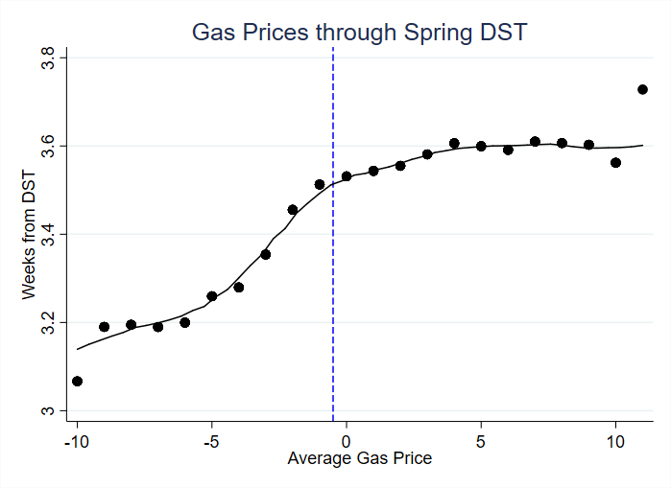

Weeks from DST

Average Gas Price

Figure 2

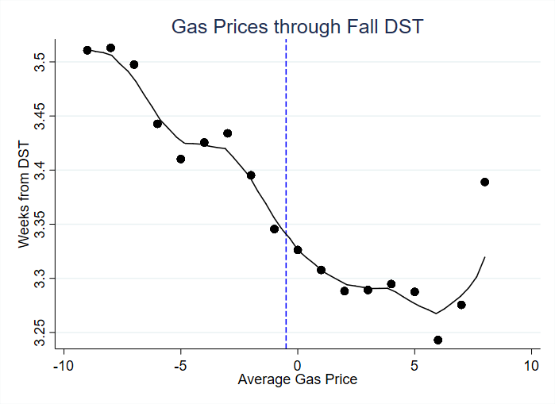

Weeks from DST

Average Gas Price

Figure 3

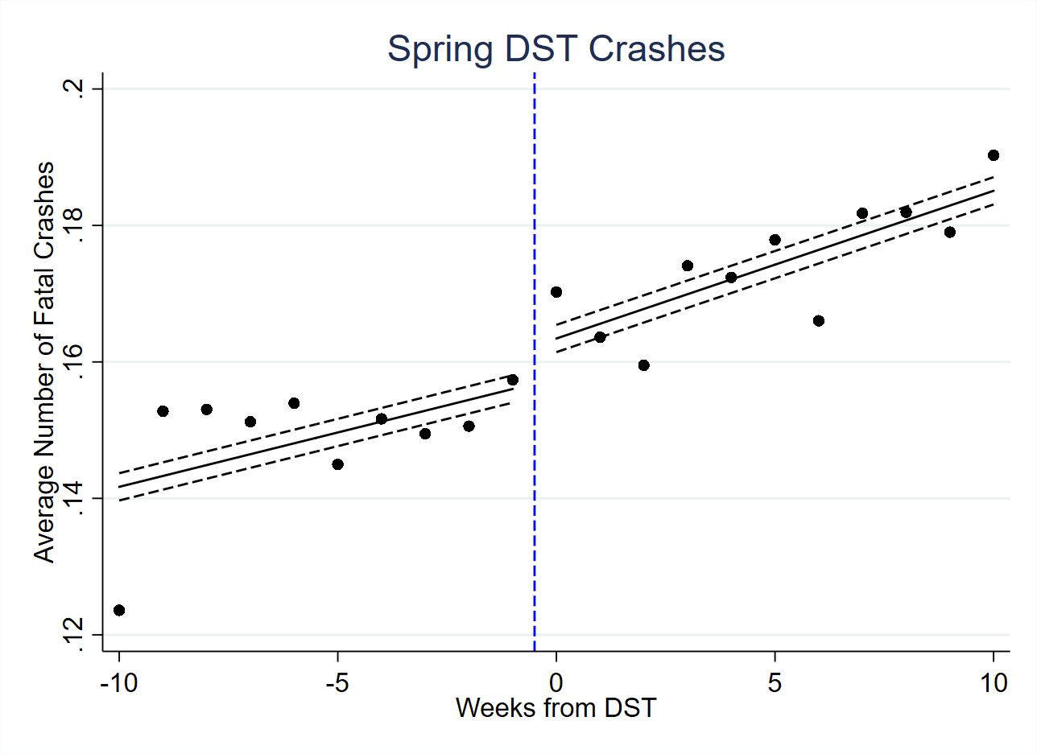

*Confidence Intervals are shown by dashed lines.*

Figure 4

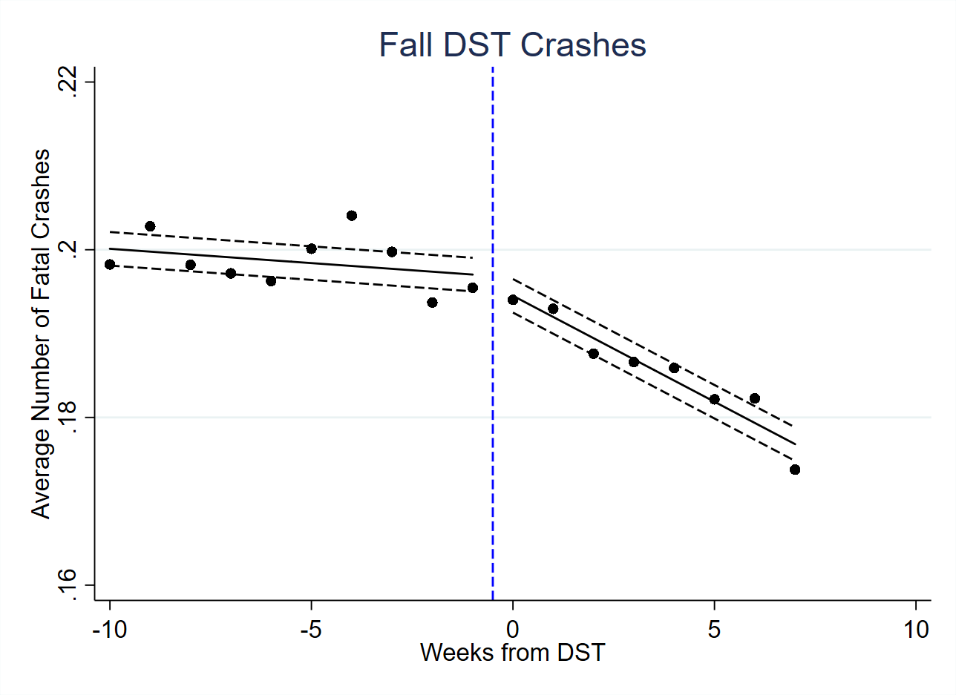

*Confidence Intervals are shown by dashed lines.*

**References**

Barnes, Christopher M and David T Wagner. 2009. “Changing to daylight saving time cuts into sleep and increases workplace injuries.” Journal of Applied Psychology 94 (5):1305.

Belzer, David B., Stanton W. Hadley, and Shih-Miao Chin, 2008, Impact of Extended Daylight Saving Time on National Energy Consumption: Technical Documentation, prepared for U.S. Department of Energy, Office of Energy Efficiency and Renewable Energy, October.

Cho, K., Barnes C. M., & Guanara, C. L. (2017). Sleepy Punishers Are Harsh Punishers: Daylight Savings Time and Legal Sentences. Psychological Science, 28, 242-247.

Farrell, Diana and Narasiman, Vijay and Ward, Marvin, Shedding Light on Daylight Saving Time (November 3, 2016). Available at SSRN: https://ssrn.com/abstract=2966170

Janszky, Imre, Staffan Ahnve, Rickard Ljung, Kenneth J Mukamal, Shiva Gautam, Lars Wallentin, and Ulf Stenestrand. 2012. “Daylight saving time shifts and incidence of acute myocardial infarction-Swedish Register of Information and Knowledge About Swedish Heart Intensive Care Admissions (RIKS-HIA).” Sleep Medicine 13 (3):237-242.

Kamstra, Mark J, Lisa A Kramer, and Maurice D Levi. 2000. “Losing sleep at the market: The daylight saving anomaly.” The American Economic Review 90 (4):1005-1011.

Smith, A. (2016) Spring Forward at Your Own Risk: Daylight Saving Time and Fatal Vehicle Crashes. *American Economic Journal: Applied Economics* 8:2, 65-91.

Wagner, David T, Christopher M Barnes, Vivien KG Lim, and D Lance Ferris. 2012. “Lost sleep and cyberloafng: Evidence from the laboratory and a daylight saving time quasi-experiment.” Journal of Applied Psychology 97 (5):1068.